**URBAN FLOW: AI-DRIVEN TRAFFIC EFFICIENCY**

**Mrs.V. SUBHA, Assistant Professor, Department of Computer Science and Applications,**

**Jeppiaar College of Arts and Science, Chennai.**

**UDITHKRISHNAN.S, Department of Computer Science and Applications,**

**Jeppiaar College of Arts and Science, Chennai.**

**BHUVANESHWARAR.T, Department of Computer Science and Applications,**

**Jeppiaar College of Arts and Science, Chennai.**

**DILLESWAR.R, Department of Computer Science and Applications,**

**Jeppiaar College of Arts and Science, Chennai.**

**ANANTHARAJ.S, Department of Computer Science and Applications,**

**Jeppiaar College of Arts and Science, Chennai.**

**ABSTRACT**

Because there are more and more cars on the road, traffic jams are becoming a regular occurrence not just in the nation but throughout the world. Numerous man hours are lost due to the regular traffic bottlenecks at busy intersections. As a result, an effective traffic control system is required. Thus, we are going to put into practice a smart traffic control system that is predicated on the real-time video processing technique for measuring traffic density. We attempted to demonstrate improvements to the current manual traffic control system through this article.

1. **INTRODUCTION**

Modern cities are becoming more and more populated, which increases the amount of vehicles on the road and exacerbates traffic congestion. We employed a video processing technology that made it simple to calculate the amount of traffic on the road. Rather of employing electrical sensors buried in the pavement, the system will identify cars based on pictures. There will be a camera placed next to the traffic signal. It is going to record picture sequences. A more effective method for managing the traffic light's status change is image processing.

For a four-way road, our suggested method calls for four cameras at a single intersection. These cameras will be attached to a CPU, which will handle video processing. This processing unit take picture from camera and compare all photo and take count the vehicle present on the road. Following a comparative analysis of the assigned time first on the road with a higher vehicle count, this process was repeated repeatedly, resulting in a reduction of traffic intersections.

Advantages

1. Heavy traffic jam reduced.

2. Decreased the pollution.

3. save human time which waste in traffic.

4. Save fuel and money.

1. **PROBLEM DEFENATION**

The conventional traffic light system is utilized in its entirety. These systems have a lot of problems, such as the fact that time isn't dependent on the quantity of cars, which has the following negative effects.

1. Heavy traffic jams.

2. Violation of traffic rules.

3. Wastage of man hours daily.

4. Increase in pollution in the consistent area.

5. Green Light for an empty road.

6. No traffic, but the pedestrians still need to wait.

7. Loss of Fuel and Money.

1. **PROPOSED SYSTEM**

The foundation of the system is the use of real-time video processing to measure traffic density. To intelligently regulate the traffic signal, the computed traffic density is compared with other traffic components. For a four-way road, this model will have four cameras at a single intersection. We will be utilizing the following hardware: an HD camera, a CPU for video processing, and n number of cameras that can be installed to alleviate traffic congestion on n highways.

A high-definition camera mounted on a pole will track the movement of cars on a road continuously and then use frame-by-frame Using real-time video analysis and our specially designed algorithm, we are able to determine the number of cars on the road.

We have created and put into place a sequential traffic timer system that is dependent on the quantity of vehicles identified. The microcontroller will initiate the sequential traffic light after detecting the signal from the CPU. The CPU will receive a signal from our micro controller, Arduino, when the light phase changes from green to red.

For practical purposes, the HD camera will be mounted in the traffic light post 19–25 feet above the street. This camera is going to record live video of the road and feed it to a computer for visual analysis.

A sequential traffic timing system that is based on the number of cars detected has been developed and implemented. Once the microcontroller detects the signal from the CPU, it will start the sequential traffic light. When the light phase shifts from green to red, our micro controller, Arduino, will send a signal to the CPU.

The HD camera will be installed at the traffic light post 19–25 feet above the roadway, for practical reasons. Live video of the road will be captured by this camera and sent to a computer for visual analysis.

1. **ALGORITHM**

The Gaussian mixture model is a probabilistic model that can be used to depict the existence of subpopulations within a larger population without requiring that the subpopulation that each individual observation belongs to be identified in an observed data set.

A distribution constructed using weighted multivariate Gaussian* distributions is known as a Gaussian mixed model. Weighting factors designate varying degrees of significance for each distribution. A superposition, or overlap, of bell-shaped curves is the resultant model.

**BASIC FORMULA FOR GMM IS**

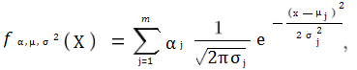

Models with Gaussian mixtures are semi-parametric. The term "parametric" denotes that the model is derived from a known distribution, in this example, a collection of normal distributions. The model can have additional components added to it, potentially from unknown distributions, making it semi-parametric.

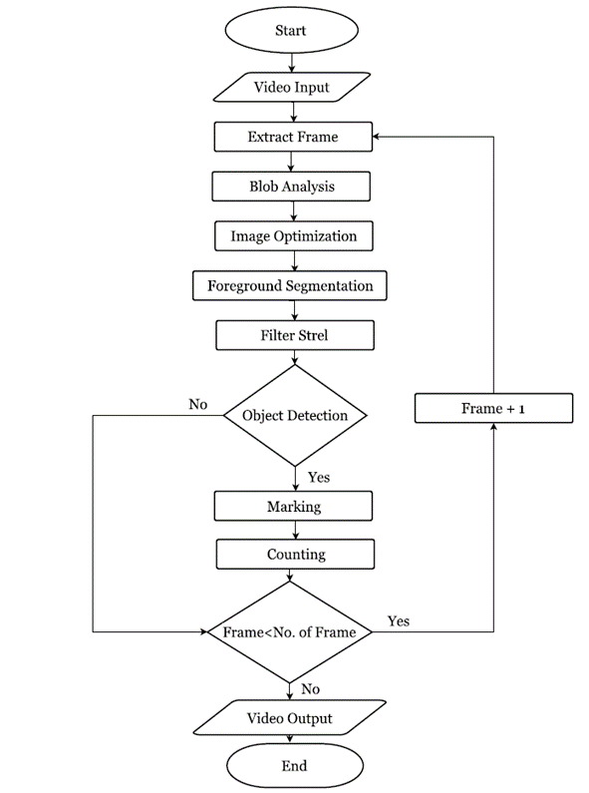

1. **IMPLEMENTATION DETAILS**

There are primarily two components to the Smart Traffic System implementation. The first component is for image processing, while the second is for signal regulating. Matlab serves as the system's front end. All video processing tasks will be handled by Matlab, and any signal control will be handled by an Arduino or controller.

**5.1 VIDEO PROCESSING USING MATLAB**

**STEP 1 - GET VIDEO AND INITALIZE FOREGROUND DETECTOR**

The example begins by collecting an initial video frame in which the moving objects are separated from the backdrop, as opposed to processing the full movie at once. This aids in introducing the video processing stages step-by-step. The Gaussian mixture model has to be initialized by the foreground detector using a specific amount of video frames. Following training, the detector starts to produce segmentation results that are more trustworthy. One of the video frames and the foreground mask that the detector calculated are displayed in the two figures below.

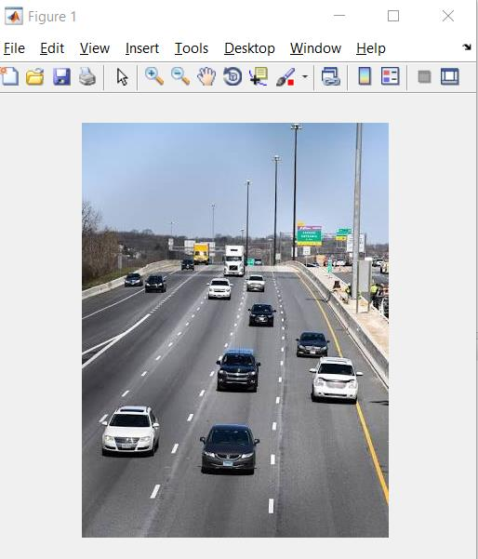

**FIG 1 : ORIGINAL IMAGE**

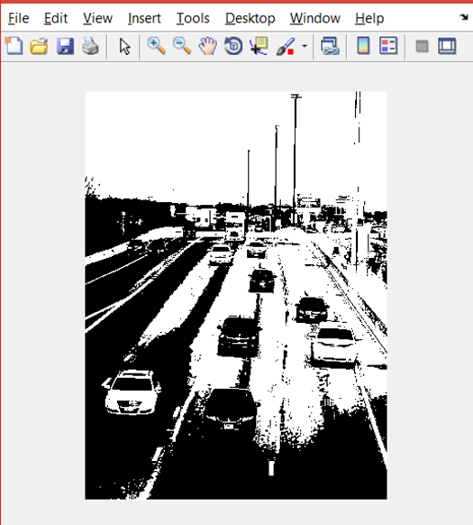

**FIG 2 : FOREGROUNDED IMAGE**

**STEP 2 - DETECT CARS IN AN INITIAL VIDEO FRAME**

Although not flawless, the foreground separation approach frequently incorporates unwanted noise. Morphological opening is used in the example to fill in the gaps and eliminate noise from the detected objects.

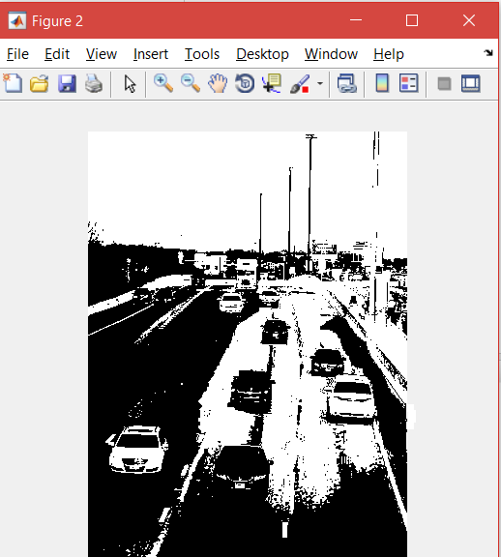

**FIG 3 : CLEAN FOREGROUND**

Next, we use a visual Blob Analysis object to discover the bounding boxes of each connected component that corresponds to a moving automobile. We draw green boxes around the cars we have detected to highlight them. The quantity of cars in the video frame is matched by the number of bounding boxes.

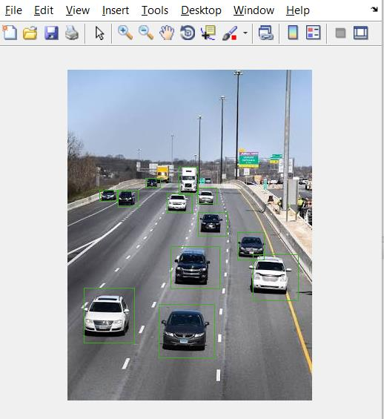

**FIG 4 : DETECTED CARS**

**STEP 3 - PROCESS THE REST OF THE VIDEO FRAMES AND SEND COUNT TO CONTROLLER**

In this step we will process the rest of the video and send the car count to the controller.

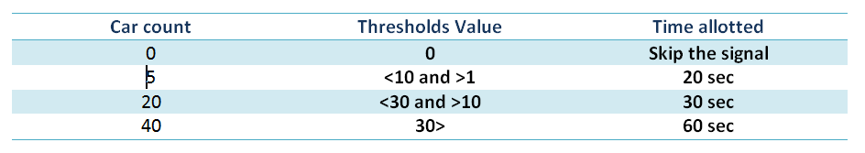

**FIG 5 : DIFFERENT THERSHOLDS**

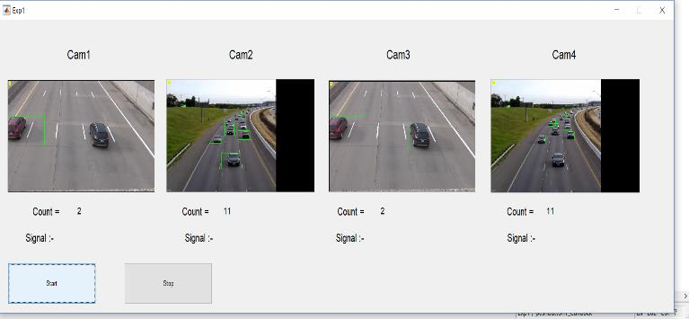

**FIG 6 : GUI OF THE IMMAGE**

We created the above GUI for the project in Matlab. In doing so, we create four windows for the video input of four distinct cameras. They counted the number of vehicles and detected every vehicle on the route. It will then be sorted in descending order and given a signal for the road with the highest traffic volume after a certain amount of time. Repeating this technique repeatedly resulted in a decrease in traffic.

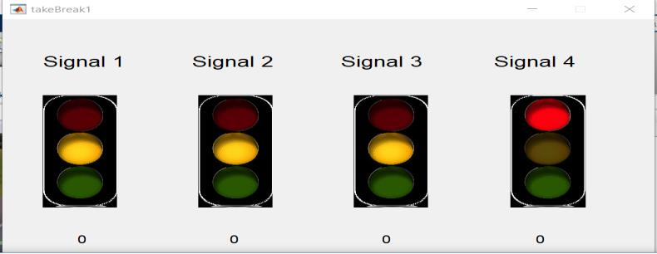

**FIG 7 : SIGNAL ALLOCATED ON DIFFERENT ROADS**

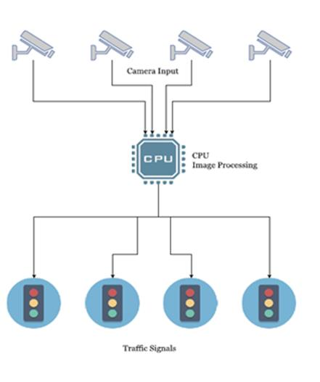

**FIG 8 : SYSTEM ARCHITECTURE**

1. **CONCLUSION**

Due to its reliability, video detection technology opened up new possibilities for vehicle tracking. There is a cost associated with the RFID equipment and maintenance, and each region must be specifically coded. Our approach, in contrast to all others, verifies excellent accuracy, and we are optimistic about its viability and success. Still, additional study and advancement in this management approach might provide that added advantage. Thus far, the technology has been designed to facilitate traffic law enforcement authorities. Enhancing the artificial intelligence of the system would require knowledge of the neighboring node's traffic pressure. In order to get beyond the drawbacks of the current approach, we expect that these approaches will be implemented as soon as feasible.

**REFERANCES**

1. Jia, R., Jiang, P., Liu, L., Cui, L., & Shi, Y. (2017). Data driven congestion trends prediction of urban transportation. IEEE Internet of Things Journal, 5(2), 581-591.
2. Zhang, H., Liu, X., Ji, H., Hou, Z., & Fan, L. (2019). Multi-agent-based data-driven distributed adaptive cooperative control in urban traffic signal timing. Energies, 12(7), 1402.
3. Lei, T., Hou, Z., & Ren, Y. (2019). Data-driven model free adaptive perimeter control for multi-region urban traffic networks with route choice. IEEE Transactions on Intelligent Transportation Systems, 21(7), 2894-2905.
4. Najafi Moghaddam Gilani, V., Hosseinian, S. M., Ghasedi, M., & Nikookar, M. (2021). Data-driven urban traffic accident analysis and prediction using logit and machine learning-based pattern recognition models. Mathematical problems in engineering, 2021, 1-11.
5. Bhatia, J., Dave, R., Bhayani, H., Tanwar, S., & Nayyar, A. (2020). SDN-based real-time urban traffic analysis in VANET environment. Computer Communications, 149, 162-175.